

Smoke Detector and Fire Alarm: Connected, Directional Path Evacuation

Senior Design 1

Initial Project Identification Document

February 2017

Group A

**Carlos Castro**, Computer Engineering

**Courtnie Coleman**, Electrical Engineering

**Lucas Plager**, Computer Engineering

**Patrick Schexnayder**, Electrical Engineering

**Motivation**

In today’s day and age, technology advancements are occurring at a rapid pace. There are new inventions being created every minute improving people’s lives and making the world a better and safer place. Our group saw that while technology is advancing and becoming a bigger part of our everyday lives, one piece of technology that has not seen a major improvement in decades is the smoke and fire alarm. This device is a standard in everyone’s homes, offices, hotels and all other major buildings that we spend time in every single day but has been neglected as far as engineering advancement and innovation is concerned. The smoke and fire alarm that you have inside your house is essentially the same one your parents had inside theirs. We think we can do better. When looking at the average use case of a smoke detector, it was discovered that while they are useful, these devices do not provide the user with an abundance of information. Frequently, someone would hear the alarm go off and just frantically run to wherever they believe to be the nearest and safest exit without much of a plan. This scenario has the potential for disaster when you consider that there could be multiple people inside the building who do not know their way around and could be endangering themselves. Individuals could be wasting valuable time or be heading in a direction that is dangerous. We believe that a smoke alarm with improved functionality can help to eliminate this scenario and make everyone’s lives easier, and most importantly, safer. This can be achieved by creating a more connected fire alarm system. When the location of a fire is a factor in directing evacuation of a building, communication between the detection system and alarm system can provide crucial, life-saving information.

**Goals, Objectives, and Function**

The goals for the smart smoke and fire alarm are to make an affordable, customizable, connected system of smoke alarms that alert employees and residents of the safest and fastest exit of the building in the case of a fire emergency. We would like this system to not be that much more expensive than existing options to convince the market to adopt our system. In the event of an emergency, these smoke alarms would sound off in an order that would lead people to the closest and safest exit. Users would just have to follow the sound that is projected from these alarms until they reach the exit to the building. These smoke alarms would be dynamic in the sense that they adapt to where the fire is located. This means that if a smoke alarm that is in the middle of a hallway goes off, people on the left of that area would be directed to the exit that is closest on their side of the fire while people on the right of that area would be directed to the exit that is closest on the other side of the fire while nobody is directed though the dangerous area. The system would also be able to handle hallway intersections and other confusing areas. This allows for residents to know where the fire is and what areas to avoid. For people that have hearing issues, these alarms will also have a visual display using light-up arrows that will point individuals in the direction they should go to exit the building. This also allows for better handling of confusing areas where sound alone could be confusing. This system should be achieved by mapping the building layout using a custom-made application during set up of these alarms, creating spatial awareness for each of the fire alarms, while using an algorithm to signal each alarm which is the best exit direction relative to its position.

**Engineering Requirements/Specifications**

The fire alarm that will be designed will give a clearer indication as to where to go during a fire. For this system to work each alarm will be connected to each other and will be able to send and receive signals. This system will be mapped to the floor plan of the building, so that when a fire breaks out the alarm system will recognize where the fire is coming from and send out a signal to each alarm to light the LEDs in the direction people should go to get away from the fire.

1. Smoke sensors

Smoke sensor will be used to detect smoke within the building, there are different types of smoke sensors to detect fast flaming fires and slow smoldering fires. Upon more research we will be decided which would be best for us to use within our fire alarm.

1. Transmitter and receiver

For this fire alarm system, we want to make sure to direct the people away from the fire and to the closest exit. For this to work we will need each alarm device to be connected to each other. So each separate alarm will have a transmitter and a receiver so that way each alarm would be able to communicate to each other, and send the correct signal.

1. Software

For the fire alarm system to be successful we will be using a script language to program the devices to recognize the layout of the building, and to be able to set off the sequence as to where to go when one of the smoke sensors go off.

1. Battery

For the fire alarm system, it will be using a 9v battery with 1200 mAh current, due to some research on current fire alarm systems and the profession grade batteries they use.

1. Lights

To help with the indication of a fire, and to help direct people in the right direction away from the fire there will be two LEDS in the shape of arrows on the fire alarm. Depending on the signal that is sent out, one of the arrows would illuminate in the direction to go. This will help give a clearer indication as to where the fire maybe and where to go.

**House of Quality**



**Block Diagram (Hardware/Software)**

../../Downloads/d97416b491834703832818b6afe67c8e.png

**Budget**

**Financing Plan**

While everyone on the team has agreed to share any financial burden created by the project equally, we will seek sponsorships and other means to finance this project. Upon selecting a project, and receiving approval we will submit proposals to companies interested in investing in fire alarms and those looking to showcase their semiconductor and component products. A tentative list includes: Texas Instruments, Taiwan Semiconductor Manufacturing, Honeywell Fire Systems, Siemens (Building Technology Division), and UCF. If no sponsorship or financial help is achieved, the team is responsible for any costs incurred.

Smoke Alarm System Budget:

|  |  |
| --- | --- |
| Wireless Adapters | $10 x 5 = $50 |
| Battery Harness / Power Supply | $3 x 5 = $15 |
| Speaker/Alarm | $1 x 5 = $5 |
| Various Electrical Components | $10 x 5 = $50 |
| Microcontroller for Hub | $30 x 1 = $30 |
| PCB boards | $10 x 5 = $50 |
| Smoke Sensors | $7 x 5 = $35 |
| Boot flasher | $15 x 1 = $15 |
| Estimated Total | $250 |

The initial estimated cost for this smart smoke detector project is $250. We will add an additional $50 to this budget to account for broken parts, errors, and items that are unaccounted for. This brings the total cost of our project to $300.

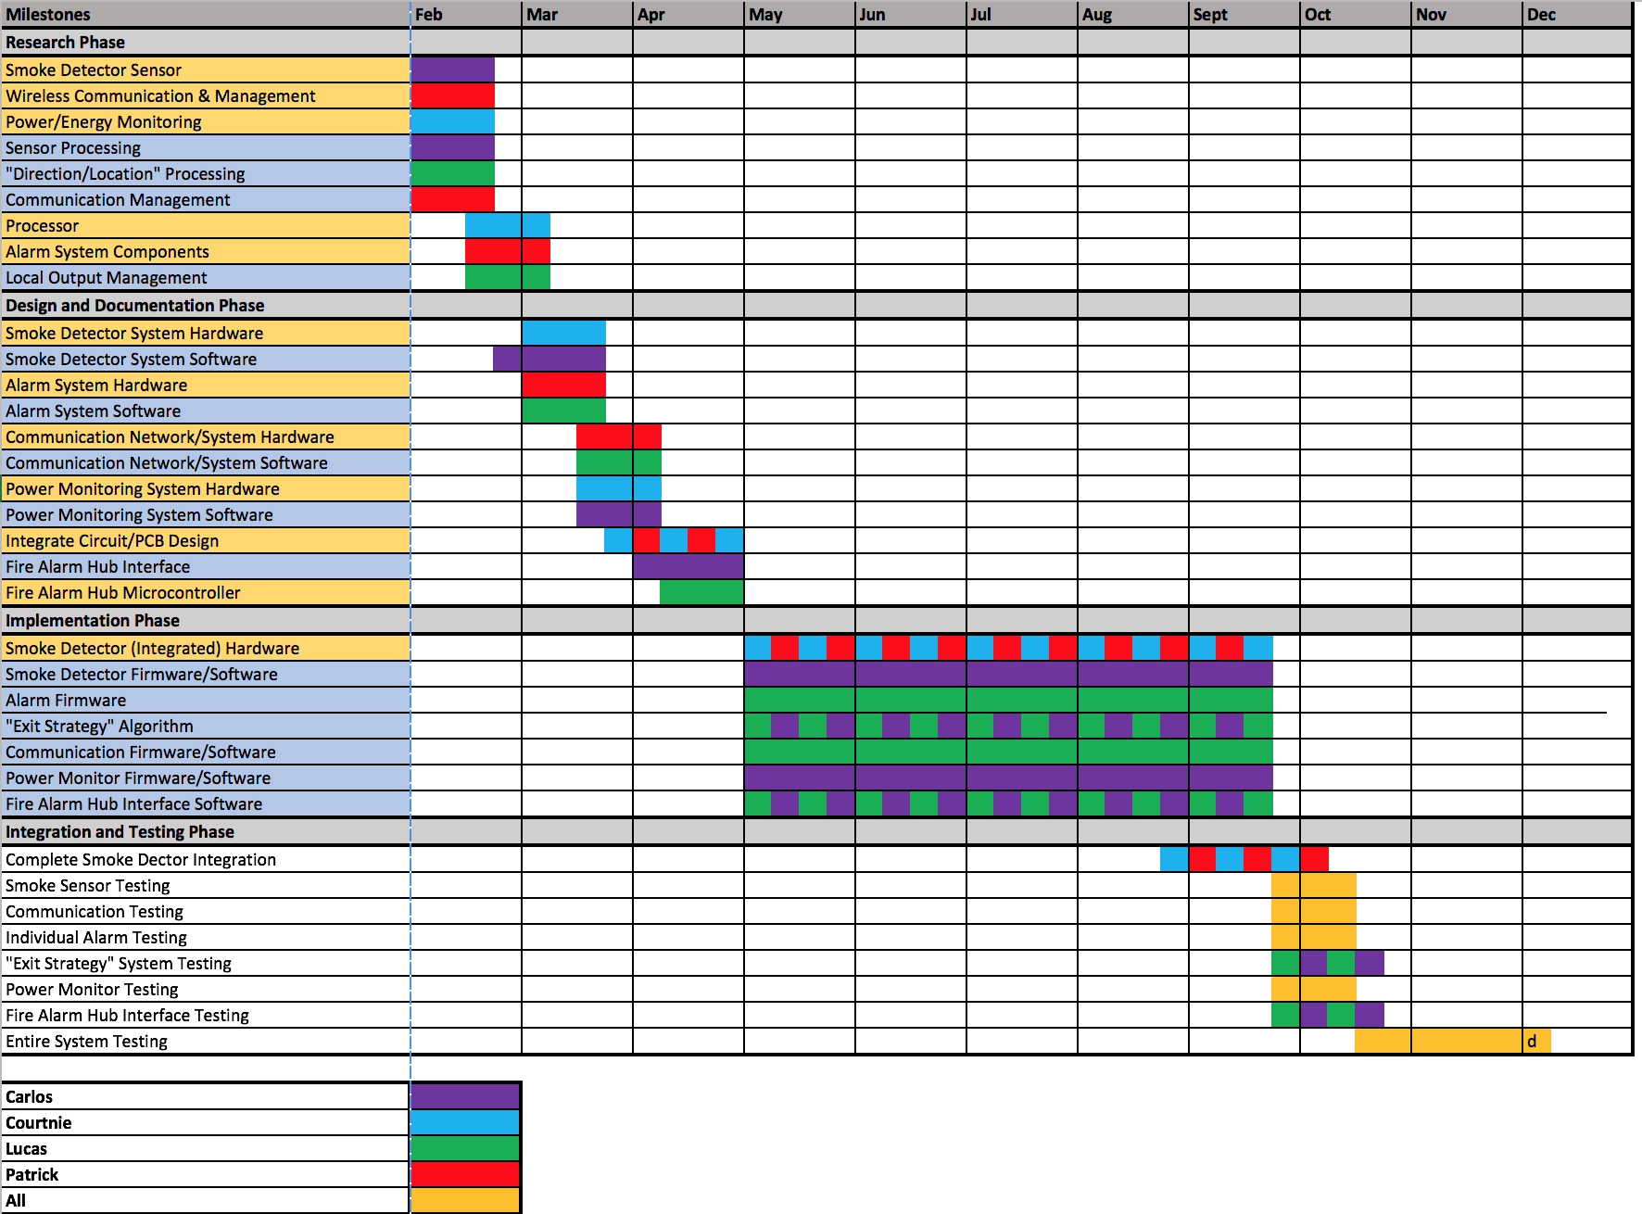**Project Timeline**



Teaching Assistant: Speech-Recognition, LCD-Display for Advanced Low Cost Learning

Senior Design 1

Initial Project Identification Document

February 2017

Group A

**Carlos Castro**, Computer Engineering

**Courtnie Coleman**, Electrical Engineering

**Lucas Plager**, Computer Engineering

**Patrick Schexnayder**, Electrical Engineering

**Motivation**

Education is the most important gift that can be provided to a person. At its most basic level, it provides someone with the baseline skills that are necessary to thrive as an adult in our ever changing society. Education has the ability to inspire, induce confidence, and make the world a better place. We feel, however, that public education can sometimes get left behind when it comes to innovation and an effort to improve. One of the major reasons behind this, as we can all assume, is government budgets and public funding. Education can be very expensive while schools and government agencies never seem to have as much funding as they need. This is the motivation for our project. One of the major initiatives for improving young education across the United States is the inclusion of iPads, tablets, and laptops into the classroom. While we believe that these devices can provide immense benefit to students, these devices can be very expensive. We sought out to design a device that students could use in conjunction with their teacher that could provide similar uses to those high cost devices but at a much better value. We believe that at a lower cost, educators, parents, and institutions would be more willing to accept technology into their classrooms.

**Goals, Objectives, and Function**

The goals for our teaching tool would be to create a low cost device that students could use to interact with and engage in challenging tasks to further their involvement in the classroom. This device would include a microphone and use speech recognition to take input from the user. This solves two issues. This allows for students at any age to be able to use the system while also limiting the amount of inputs to the system in order to keep the price low. The device would also include a small display so that users could read questions and tasks from the device. A large enough power supply would have to be included so that this device could be portable and used for a suitable amount of time. Lastly, this device would include memory and USB connectivity to store results and transmit those results to a teacher in class. I strong example for this device would be young students trying to learn the alphabet or their multiplication tables. A teacher could give an assignment to the students where they are to study multiplication when they get home. The student would take out the device and the device would ask for the answer to simple math problems. The student would then say the answer into the device and the device would either accept the answer or tell the student that they were wrong and try again. The device would store the statistics for how well they are doing on this assignment and when the student comes in to class the next day, could transmit this data to the teacher. The student could also use the device as much as they liked and use it as a fun study tool. The teacher could then see how well the class is doing and how much they studied and practiced. We believe this device would be useful to both students and teachers and increase involvement inside and outside of the classroom, while also providing a valuable education tool and a fraction of the cost of other technologically immersive devices.

**Engineering Requirements/Specifications**

The teaching assistant will be used to help kids learn their numbers, the alphabet, languages, math, etc. by using speech recognition. With this tool the teachers would be able to monitor and analyze the data received from this device and shall be able to adjust their teaching style to address the trouble areas monitor by this device.

1. Speech recognition software

The teaching assistant device will be capable of Speech recognition software to detect the response of the user. With the speech recognition software being capable to collect the users’ response allows the device to analyze the data collect and check if the spoken answer was correct or incorrect. Being able to detect the if the correct answer was spoken or not will decided whether the program can move on to the next step.

1. User interface

For the teaching assistant a user interface will be designed so the users can have the appropriate interaction with the device. The user interface will not be too advance so that kids would be able to use it with ease.

1. LCD screen

A LCD screen will be used for the teaching assistant device. LCD screens have a wide range of brightness, which will produce bright images. This is very suitable to environments that are brightly lit, like class rooms, so the kids using it will be able to see the images clearer due to the anti-glare technology. The LCD screen is also light weight which will help with the portability aspect of this device. Also LCDs produce low electricity, so this will not drain the battery of the device.

1. Battery

For the teaching assistant it will be using a 5V rechargeable battery, and this conclusion was due to researching of other kid edition tablet devices.

1. Microphone

A microphone will be incorporated in the teaching assistant for the speech recognition aspect of this device. The microphone will be low cost which is great for the cost of production, and would be uncomplicated to install into the device.

**House of Quality**



**Block Diagram (Hardware/Software)**



**Budget**

**Financing Plan**

While everyone on the team has agreed to share any financial burden created by the project equally, we will seek sponsorships and other means to finance this project. Upon selecting a project, and receiving approval we will submit proposals to companies interested in investing in fire alarms and those looking to showcase their semiconductor and component products. A tentative list includes: Texas Instruments, Taiwan Semiconductor Manufacturing, Local Public School District (OCPS, SCPS, etc.), Kramer Electronics and UCF, in addition to possibly attending EdTech Orlando Conference in February to network with possible sponsors. If no sponsorship or financial help is achieved, the team is responsible for any costs incurred.

Teaching Assistant Budget.

|  |  |
| --- | --- |
| Microphone/Voice Control Module | $25 x 3 = $75 |
| Speaker | $2 x 3 = $6 |
| Display | $10 x 3 = $30 |
| Memory/Ram | $5 x 3 = $15 |
| Rechargeable Battery | $20 x 3 = $60 |
| Microcontroller/Miscellaneous Parts | $15 x 3 = $45 |
| PCB boards | $10 x 3 = $30 |
| Wifi Adapter | $10 x 3 = $30 |
| Boot Flasher | $15 = 1 = $15 |
| Estimated Total | $306 |

The initial estimated cost for the teaching assistant project is $306. \ We will add an additional $44 to this budget to account for broken parts, errors, and items that are unaccounted for. This brings the total cost of our project to $350.

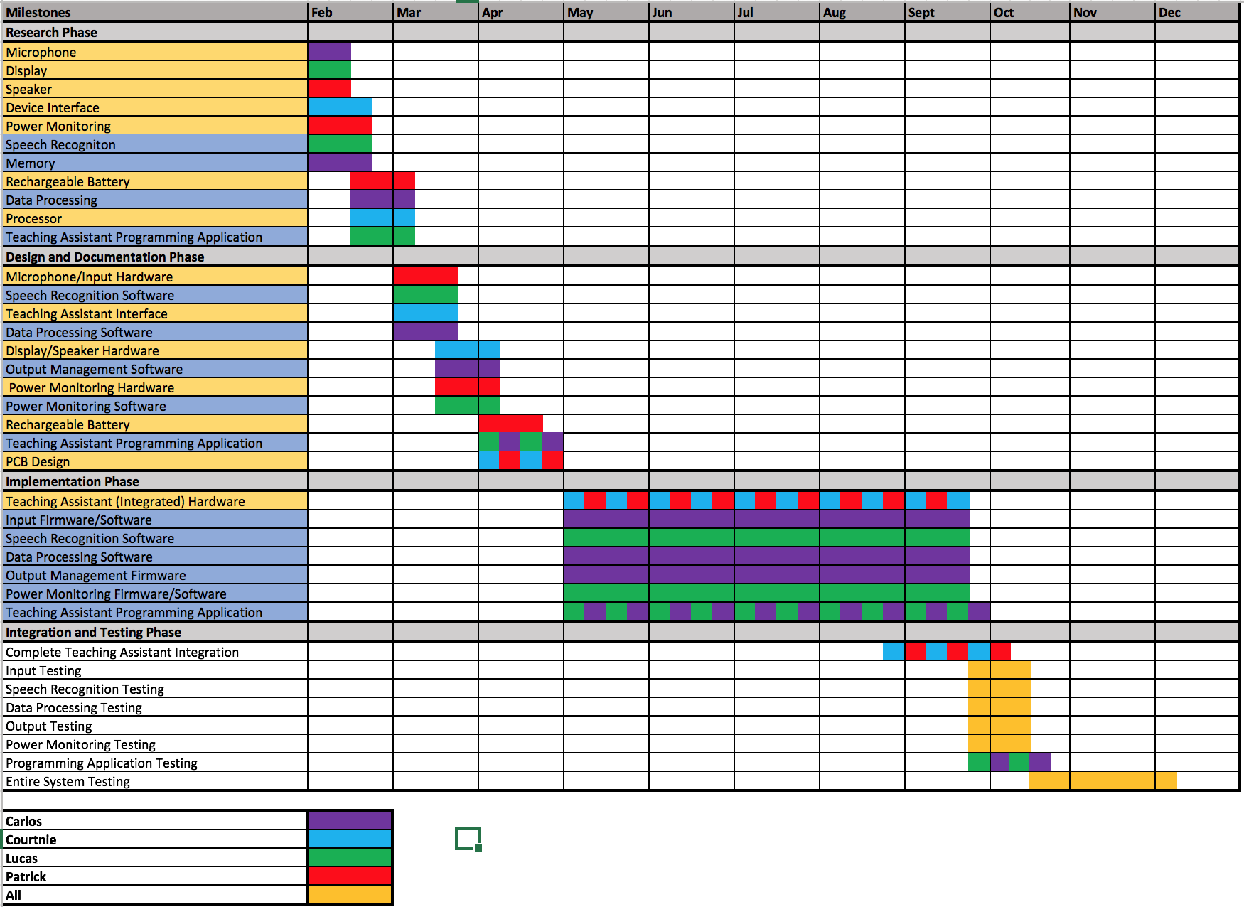**Project Timelin**

**Decision Matrix**

The diagram shown below is a decision matrix between the Smart Smoke and Fire Alarm project and the Teaching Assistant project. The attributes listed inside will be factors used to make this decision.

